## -------------------------------------------------------------------------------------------------------

## CS5542 - Lab Assignment 2 – Lab Report

## Sub team # 1-2 | Avni Mehta (Class Id: 11) | Raji Muppala (Class Id: 14)

## -------------------------------------------------------------------------------------------------------

**Objective:**

Take images related to project and build Random Forest, Decision Tree, Naïve Bayes models and compare the accuracy

**Input:**

Took Images from COCO VAQ project. Identified 4 categories - **"animals"**,**"food"**,**"Interiors"**,**"people"**

Divided data into train and test4 (for test data)

**Code:**

Both team members came up with different ways to achieve the goal.

Modified IPApp code, changed image categories . Used same code to generate clusters, features, histograms.

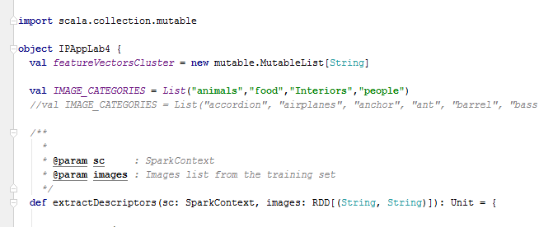

Decision Tree model code:

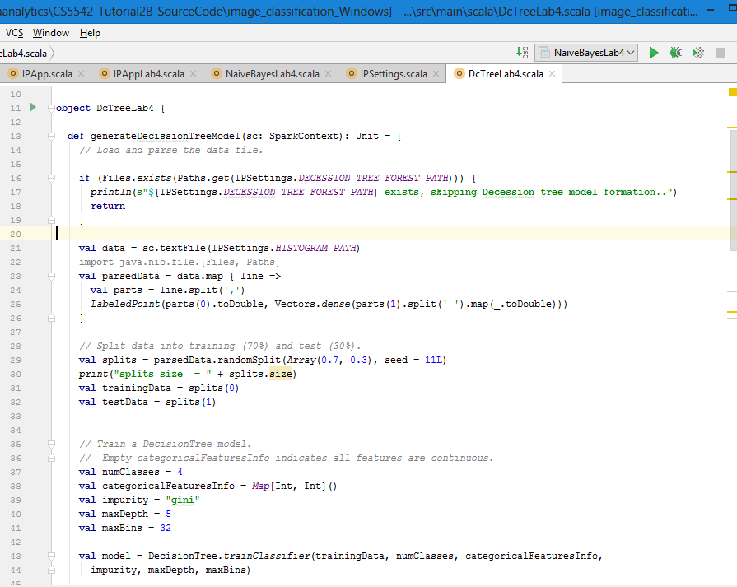

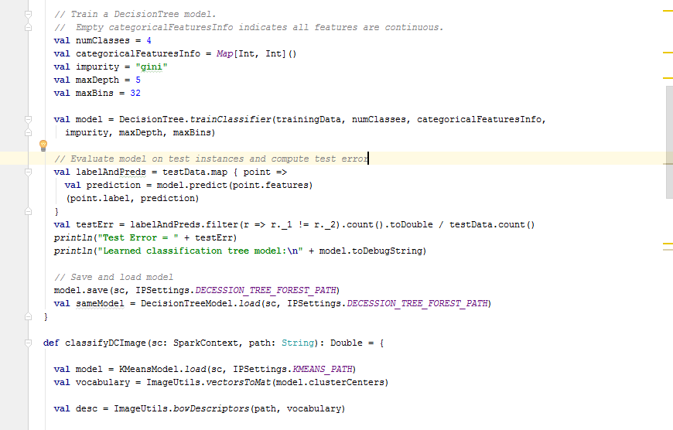

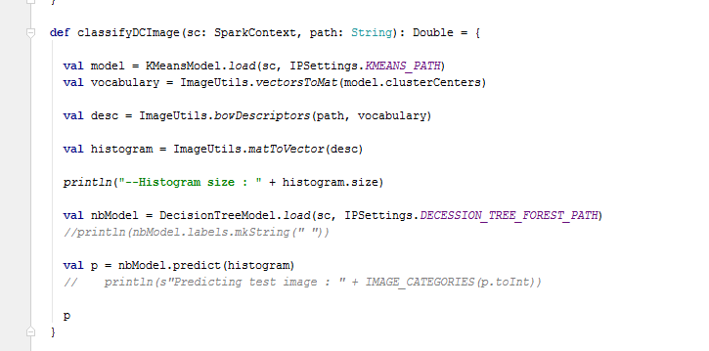

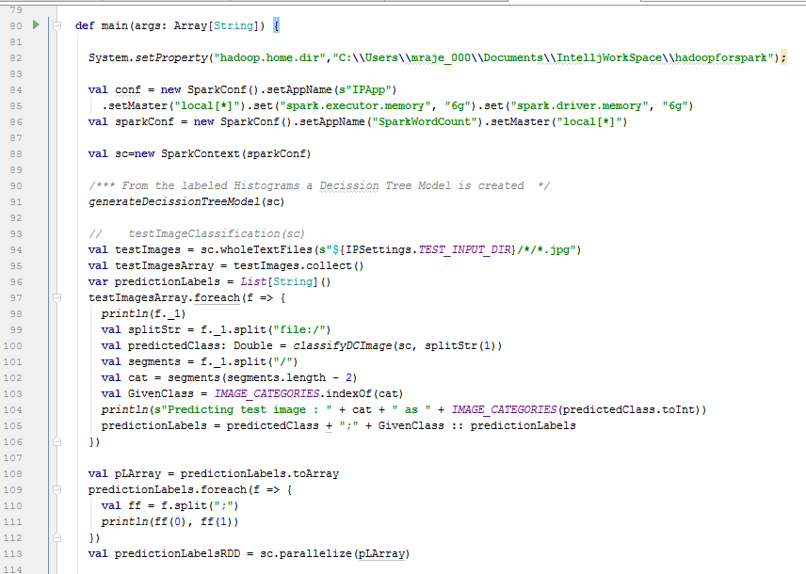

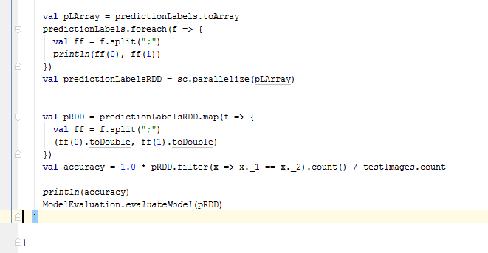

**Naive Bayes Model:**

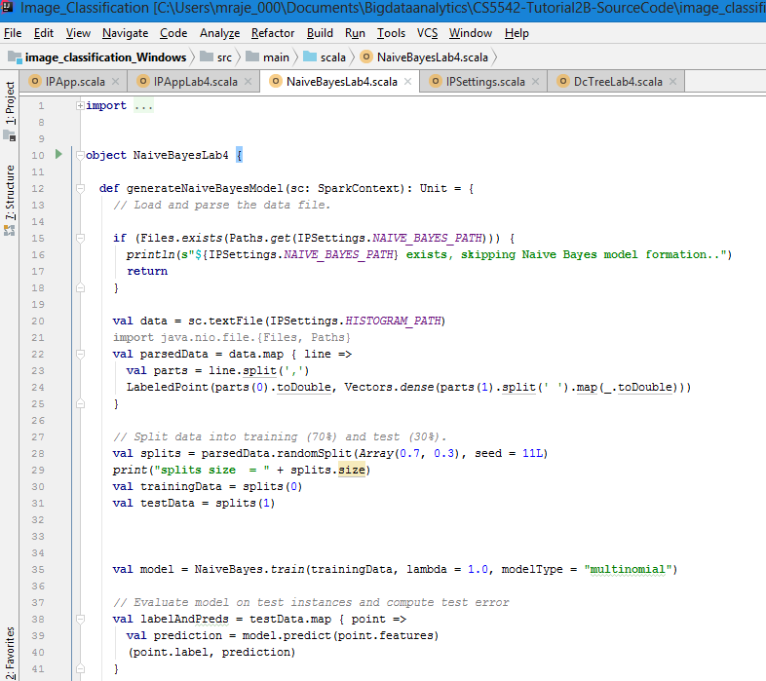

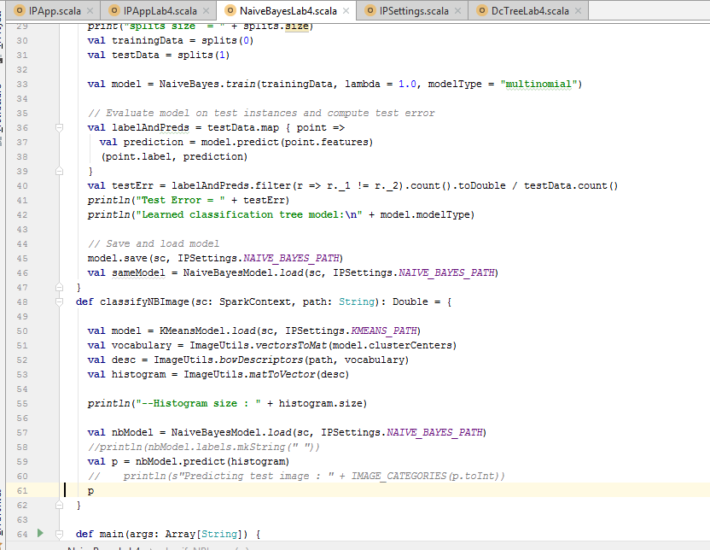

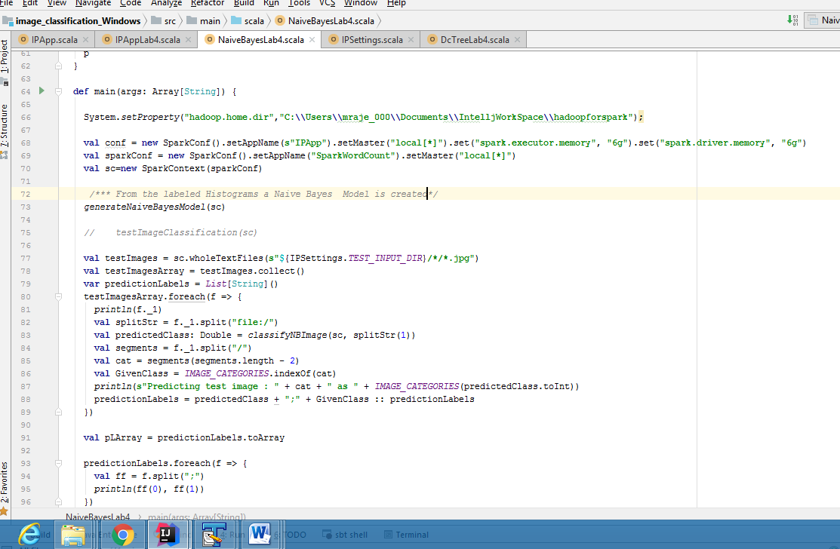

**Output:**

**Used COCO data , picked images following 4 categories:**

**"animals"**,**"food"**,**"Interiors"**,**"people"**

**Random Forest :**

|=================== Confusion matrix ==========================

27.0 2.0 1.0 6.0

3.0 10.0 0.0 3.0

3.0 0.0 8.0 1.0

1.0 2.0 1.0 8.0

Accuracy - 0.6973684210526315

**Decision Trees:**

|=================== Confusion matrix ==========================

26.0 0.0 9.0 1.0

5.0 6.0 3.0 2.0

6.0 0.0 6.0 0.0

4.0 0.0 4.0 4.0

Accuracy - 0.5526315789473685

**Naïve Bayes:**

|=================== Confusion matrix ==========================

36.0 0.0 0.0 0.0

16.0 0.0 0.0 0.0

12.0 0.0 0.0 0.0

12.0 0.0 0.0 0.0

Accuracy - 0.47368421052631576

Random forest got good accuracy than Decision Trees model , Naïve Bayes